FAST FOURIER TRANSFORM, AC AND TRANSIENT ANALYSIS OF AN INVERTING AMPLIFIER

Aim: To determine the non ideal characteristics of an op-amp using various types of analysis. (Transient, AC and FFT)

Op-amp parameters: Out of several existing parameters of the op-amp, the ones that are responsible for behaviour of non ideal characteristics of the integrated circuit
are slew rate, slew rate limiting frequency, attenuation of bandwidth, linear and non linear distortion.

Slew rate: Slew rate is defined as the maximum rate of change of output per unit of time and is expressed in terms of volts per micro second. Slew rate indicates how rapidly the output of an op-amp can change in response to changes in the input frequency. The slew rate changes with change in voltage gain and is normally specified at unity gain. The slew rate of the op-amp is fixed, therefore, if the slope requirements of the output signal is greater than the slew rate then distortion occurs.

Non linear distortion: Non linear distortion is used to describe the phenomenon of non-linear relationship between the input and the output. Whenever this distortion occurs, the output will no longer be following the input linearly or proportionally. For a practical non-ideal amplifier, the amplification may not produce a linear signal over a wide range of frequencies.

Introduction:
An inverting amplifier is mainly composed of an op-amp and some passive components, mainly resistors along with a signal source to feed an input signal. In this amplifier only one input is applied to the inverting input terminal and the non inverting terminal is grounded, hence the name of the amplifier.

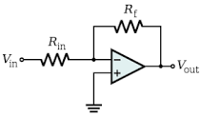

To find the gain of the above inverting amplifier:
(Let gain be ‘A’)
V_{out}/R_{f} = -V_{in}/R_{in}
V_{out}/V_{in}=A
Therefore A= -R_{f}/R_{in}
The negative sign indicates that output voltage is out of phase w.r.t input by 180 degrees or is of opposite polarity. Thus in an inverting amplifier the input signal is amplified by gain A and is also inverted at output.

Schematic and simulation working:
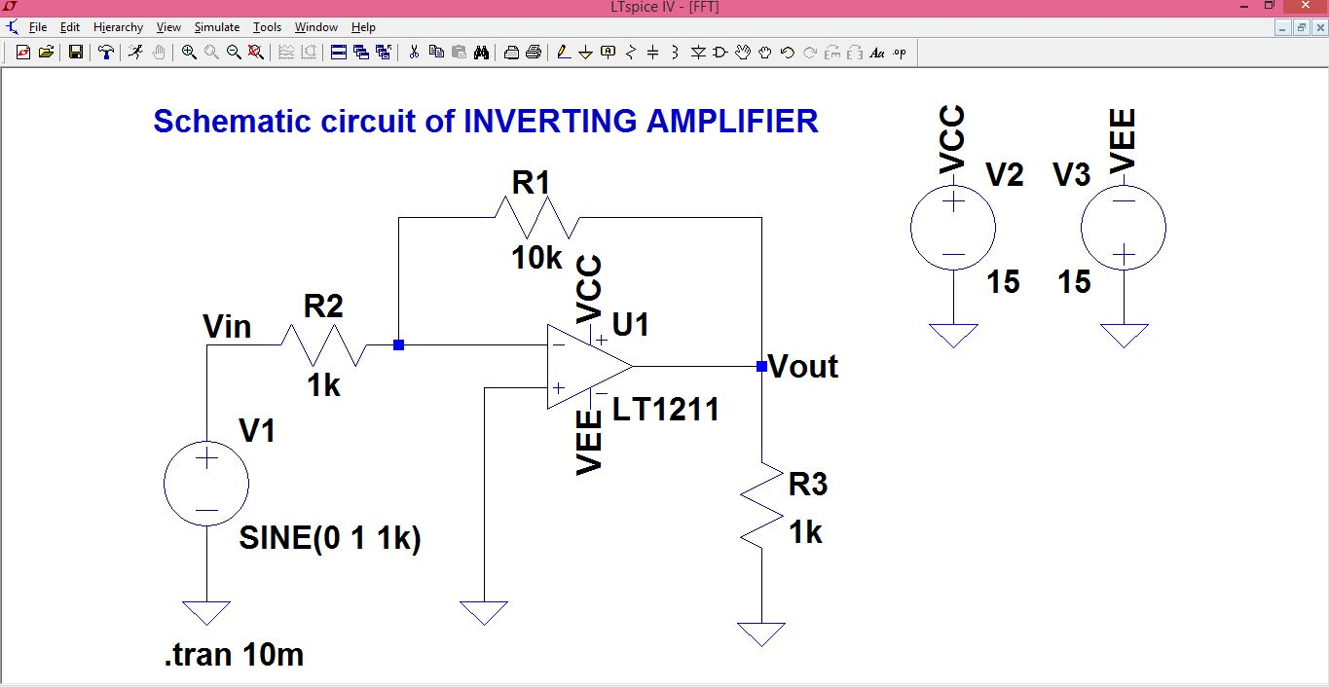
Fig.1

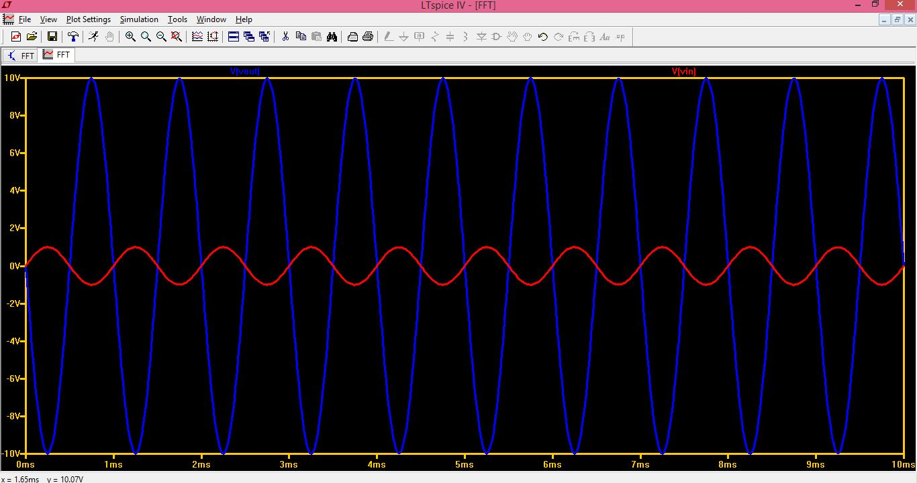
Fig2.

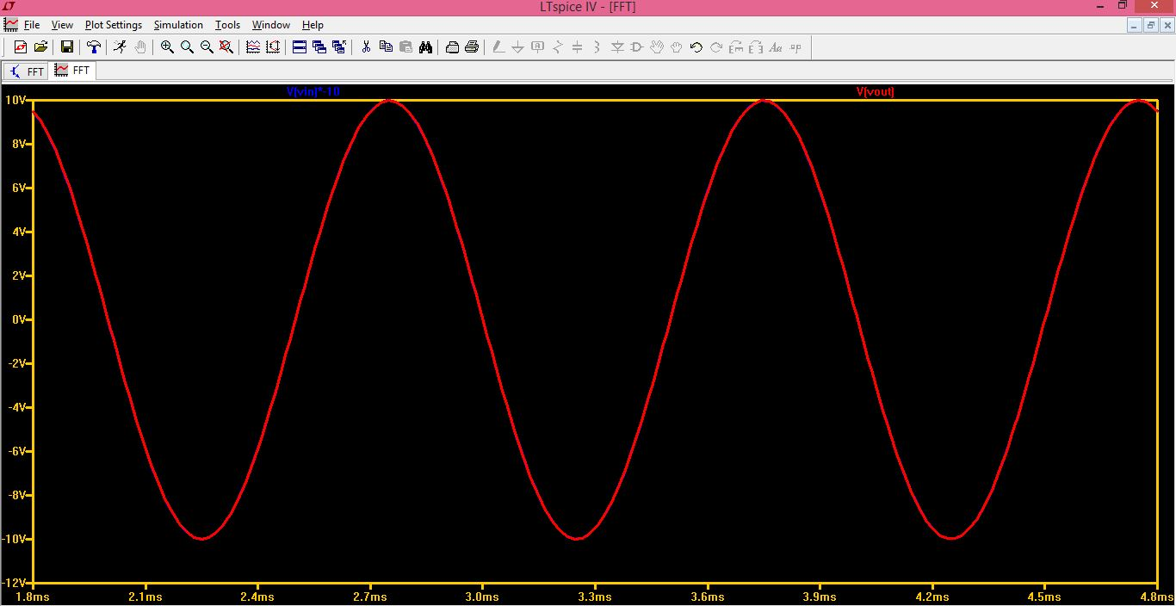
Fig3.

In the transient analysis Fig1. Is a schematic having a sine wave of 1kHz, since the gain of the amplifier is -10, the output of an inverted phase waveform with a smaller magnitude is observed in Fig.2. In order to observe the superimposition of waveforms, the input voltage can be multiplied by -10 for compensating towards the output voltage and the waveforms of the same can be seen in Fig.3

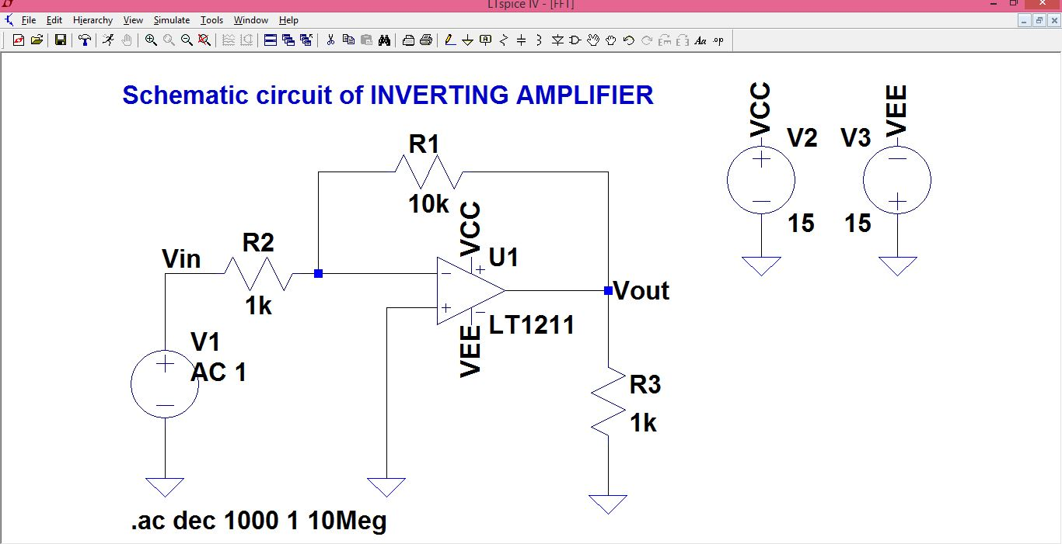
Fig.4
From the AC analysis it is observed that there is an attenuation in the output wave starting from about 150Khz. Which means that after that frequency, the output will no longer be following the input sinosoidally and increasing frequency will give rise to a non-linear distortion due to the limitation of slew rate. The schematic and simulation is in Fig4. And 5 respectively.

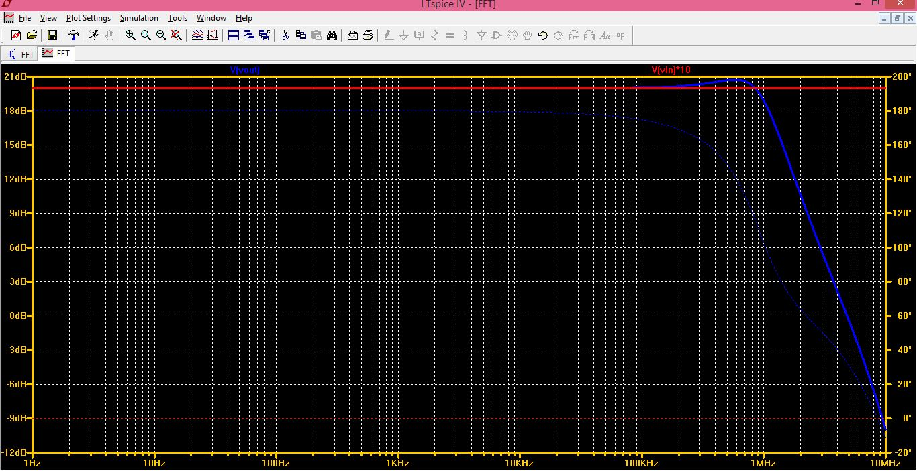
Fig.5

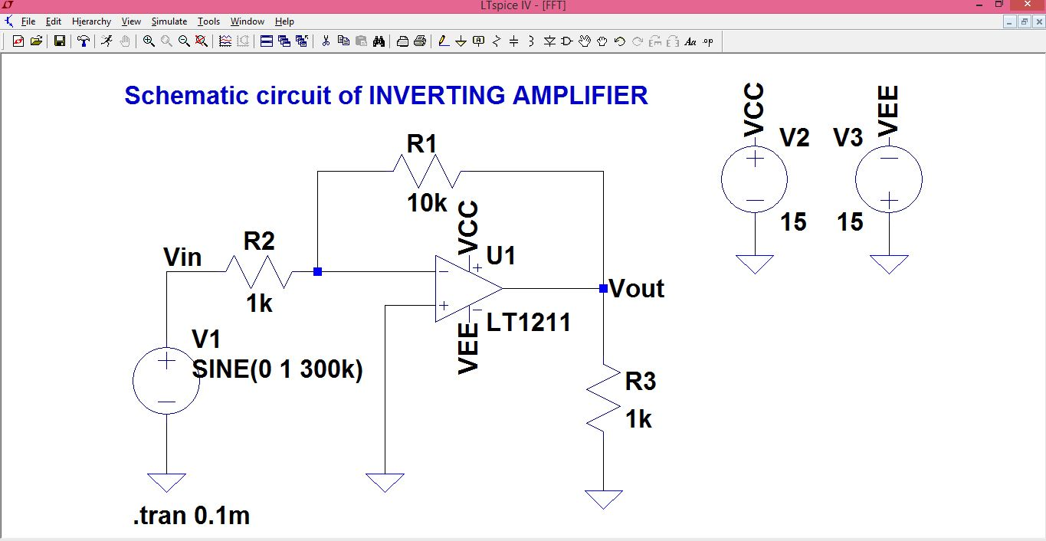
Fig.6

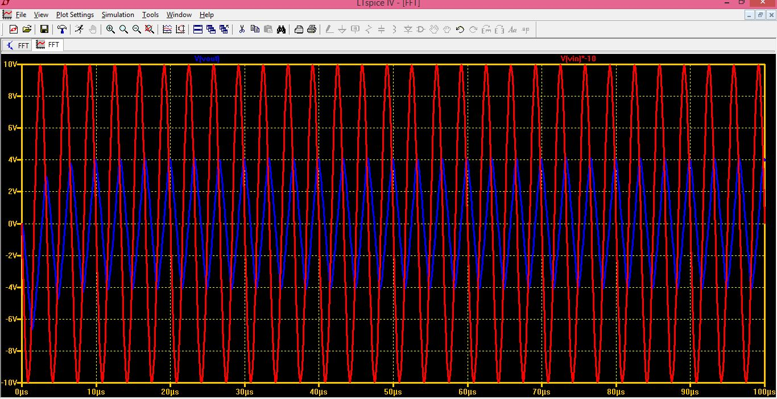
Fig.7

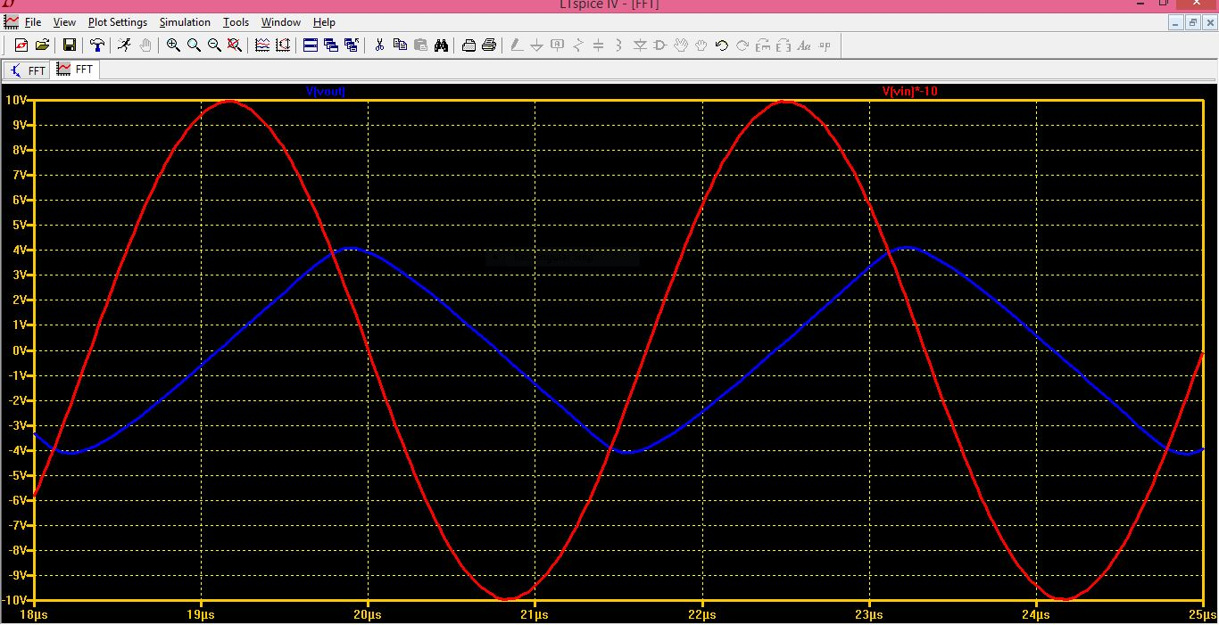
Fig.8

W.r.t. Fig.6,7 and 8, the for a sine wave of 300KHz, it is proven that the output is no longer following the input. The output is changing at about 7V per microsecond which is infact the slew rate of the op-amp LT1211. Fig.8 is the zoomed version of Fig.7 where the input voltage is compensated to be equal to the output voltage so that the op-amp properties can be compared.

Fig. 9,10,11 and 12 are the fast fourier transform(FFT) waveforms of schematic Fig.1 and 6. for sine wave of frequencies 1KHz and 300KHz respectively. To calculate FFT, right click on the simulation window ->view-> FFT-> select the Blackman window option and the desired parameter and observe the waveform in linear representation of the vertical Y axis. Fig.9 and 11 are the normal input waveforms for sine value 1KHz and 300KHz frequency respectively. And Fig. 10 and 12 are the respective output waveforms. In Fig.10 the waveform shows no undesired harmonics while the 300KHz output waveform shows a few harmonics of non-linear distortion, proving the above AC and transient analysis.

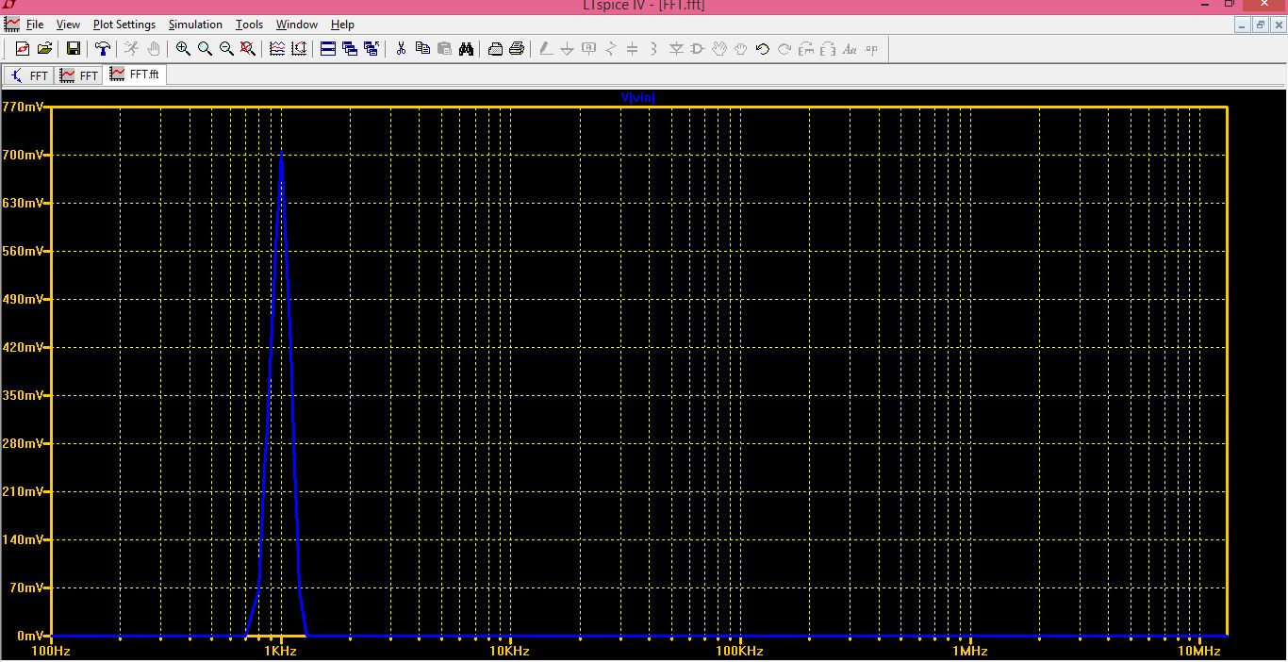
Fig.9

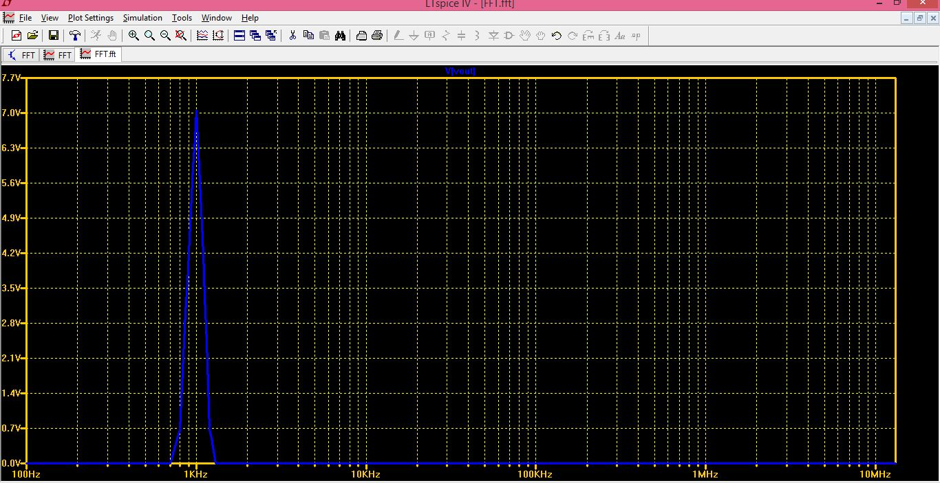
Fig.10

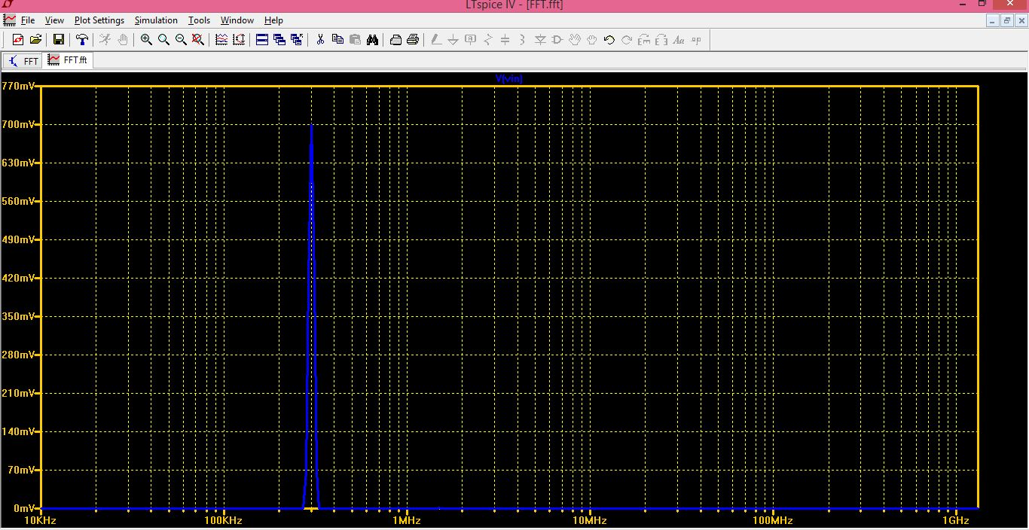
Fig.11

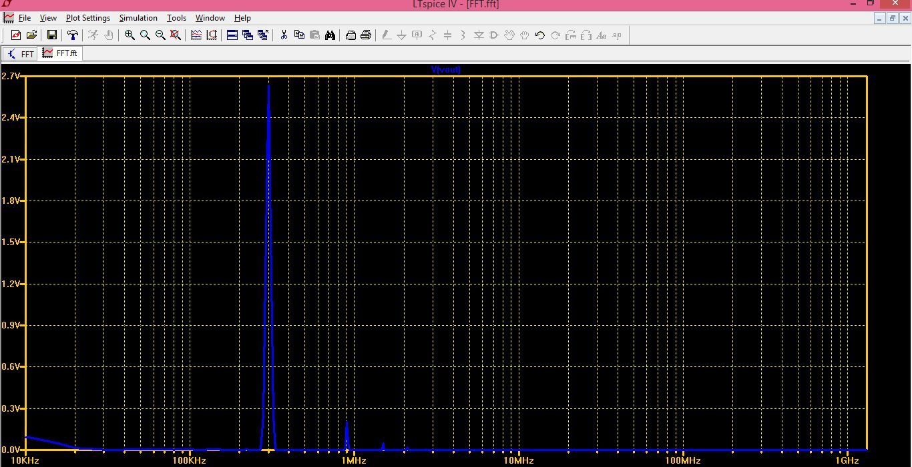
Fig.12

